**Jamie Campbell**

**6 May 2016**

**BI 471**

**HW #4 Question #2**

**For t = 1:20**

library("deSolve")

comp <- function(t, y, p) {

N1 <- y[1]

N2 <- y[2]

with(as.list(p), {

dN1.dt <- (r1 * N1 / K1) * (1 - N1 - a12 * N2)

dN2.dt <- (r2 * N2 / K2) * (1 - N2 - a21 * N1)

return(list(c(dN1.dt, dN2.dt)))

})

}

## specify parameter values and initial conditions

p <- c('r1' = 0.1, 'K1' = 2, 'r2' = 0.6, 'K2' = 1,

'a12' = 0.15,

'a21' = 0.3)

y0 <- c('N1' = 0.1, 'N2' = 0.1)

t <- 1:20

## simulations

sim <- ode(y = y0, times = t, func = comp, parms = p, method = 'lsoda')

sim <- as.data.frame(sim)

## plot time series

plot(N1 ~ time, data = sim, type = 'l', col = 'darkgreen', ylim = c(0, 2), bty = 'l')

points(N2 ~ time, data = sim, type = 'l', col = 'purple', lty = 2)

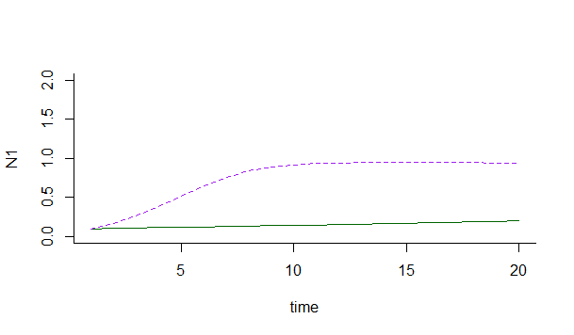

## plot phase space and attractor

plot(N1 ~ N2, data = sim, type = 'l', ylim = c(0, 2), bty = 'l')

points(sim$N1[nrow(sim)] ~ sim$N2[nrow(sim)], pch = 21, bg = 'red', cex = 2.5)

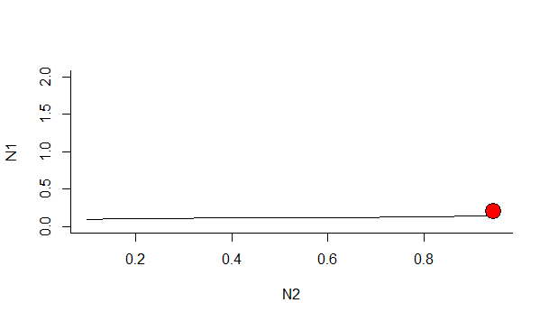

plot(N2 ~ N1, data = sim, type = 'l', ylim = c(0, 1.1), bty = 'l')

points(sim$N2[nrow(sim)] ~ sim$N1[nrow(sim)], pch = 21, bg = 'darkgreen', cex = 2.5)

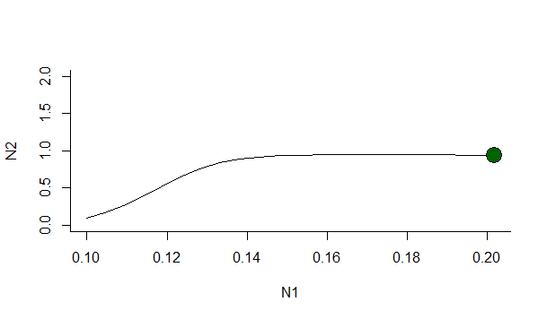

## From these results, I would predict that species N2 would out-compete species N1.

**For t = 1:100**

library("deSolve")

comp <- function(t, y, p) {

N1 <- y[1]

N2 <- y[2]

with(as.list(p), {

dN1.dt <- (r1 * N1 / K1) * (1 - N1 - a12 * N2)

dN2.dt <- (r2 * N2 / K2) * (1 - N2 - a21 * N1)

return(list(c(dN1.dt, dN2.dt)))

})

}

## specify parameter values and initial conditions

p <- c('r1' = 0.1, 'K1' = 2, 'r2' = 0.6, 'K2' = 1,

'a12' = 0.15,

'a21' = 0.3)

y0 <- c('N1' = 0.1, 'N2' = 0.1)

t <- 1:100

## simulations

sim <- ode(y = y0, times = t, func = comp, parms = p, method = 'lsoda')

sim <- as.data.frame(sim)

## plot time series

plot(N1 ~ time, data = sim, type = 'l', col = 'darkgreen', ylim = c(0, 2), bty = 'l')

points(N2 ~ time, data = sim, type = 'l', col = 'purple', lty = 2)

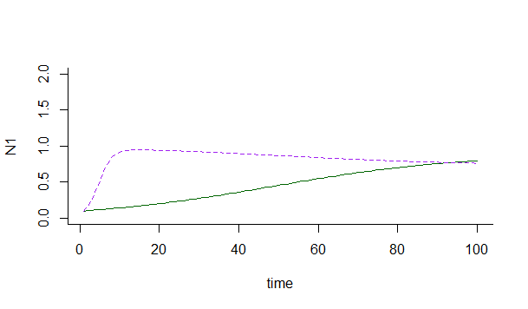

## plot phase space and attractor

plot(N1 ~ N2, data = sim, type = 'l', ylim = c(0, 2), bty = 'l')

points(sim$N1[nrow(sim)] ~ sim$N2[nrow(sim)], pch = 21, bg = 'red', cex = 2.5)

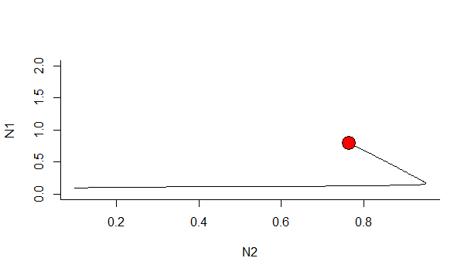

plot(N2 ~ N1, data = sim, type = 'l', ylim = c(0, 2), bty = 'l')

points(sim$N2[nrow(sim)] ~ sim$N1[nrow(sim)], pch = 21, bg = 'darkgreen', cex = 2.5)

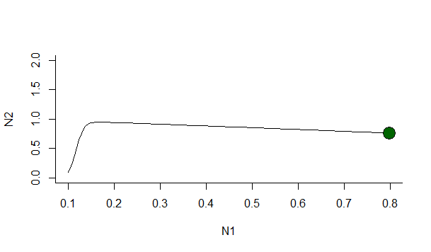

## From these results, I would predict that species N1 would out-compete species N2.

Short- and long-term ecological experiments can be interpreted differently because long-term experiments show that models may not hold constant with time, and in the case Lotka-Volterra models, it is possible for isoclines to change direction, although the corresponding equation and short-term experiments may predict otherwise.